Advanced Computer Networking and Security - 5800

Assignment -5

TCP/IP Attack Lab

Name:Jonnada Sai Rohit

ID : 700723743

Turning on the docker 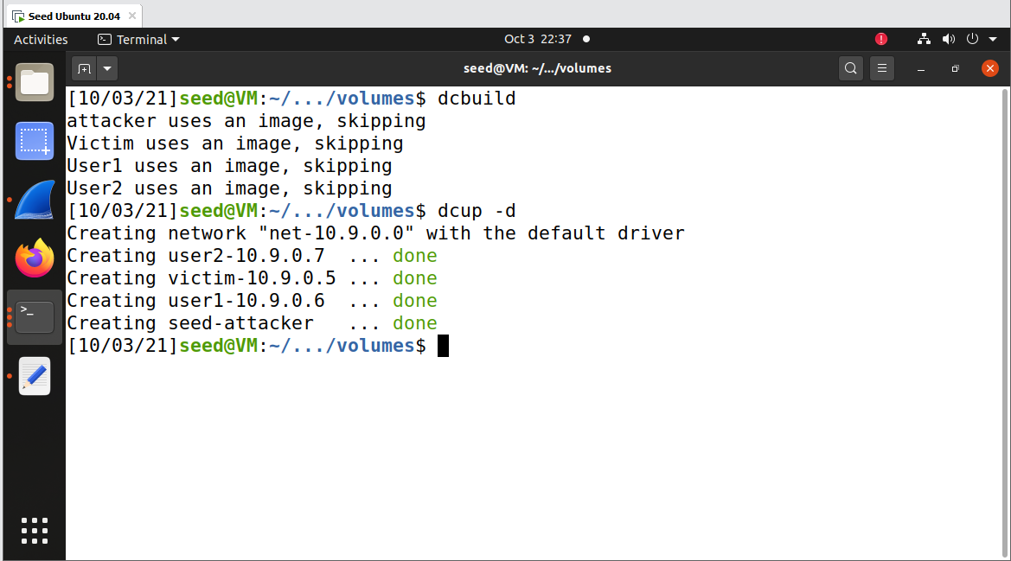

Checking the size of the queue for system wide setting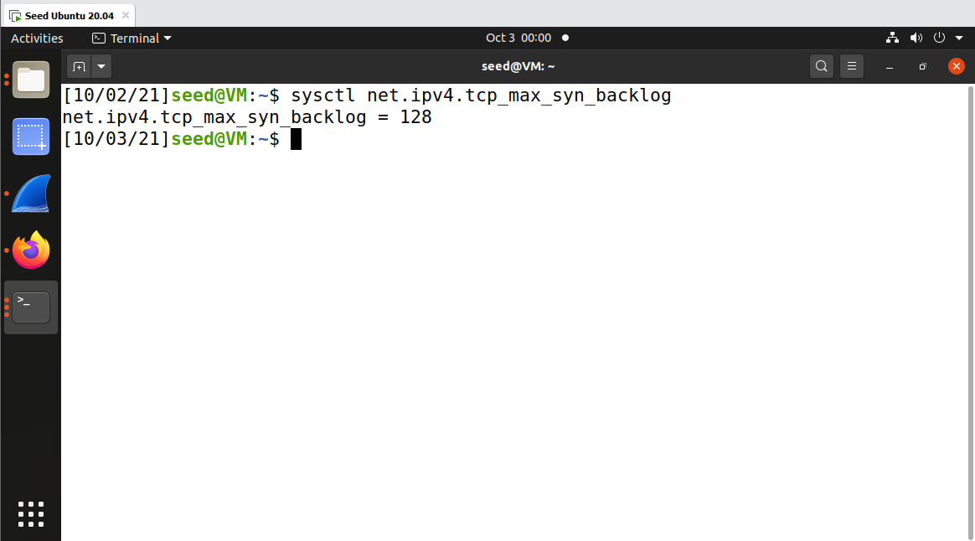

Checking the current open ports which are awaiting connections, the established connection shows that 3-way handshake is completed

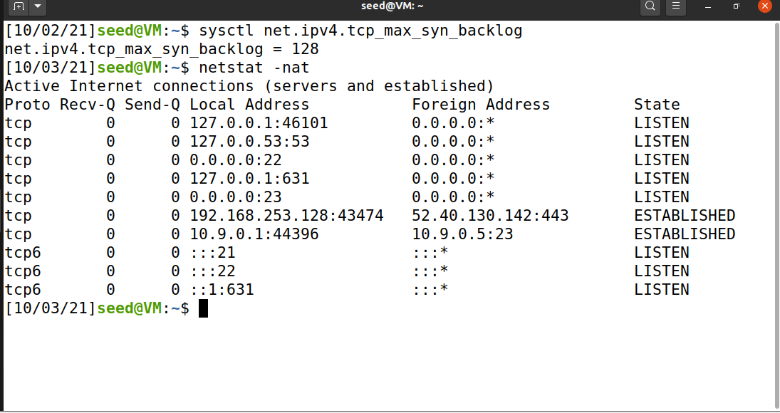

Checking SYN Cookie Countermeasure whether is turned on or off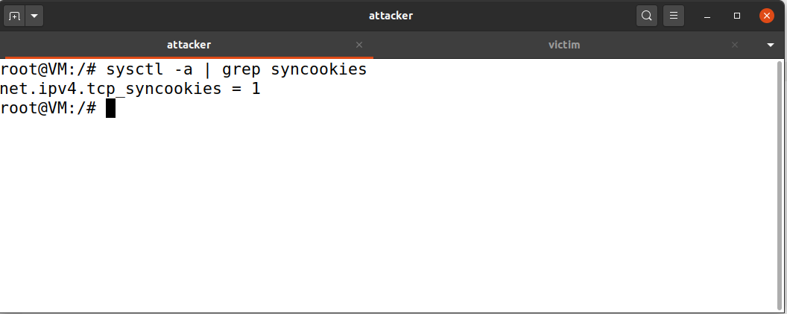

Turning off the SYN Countermeasure

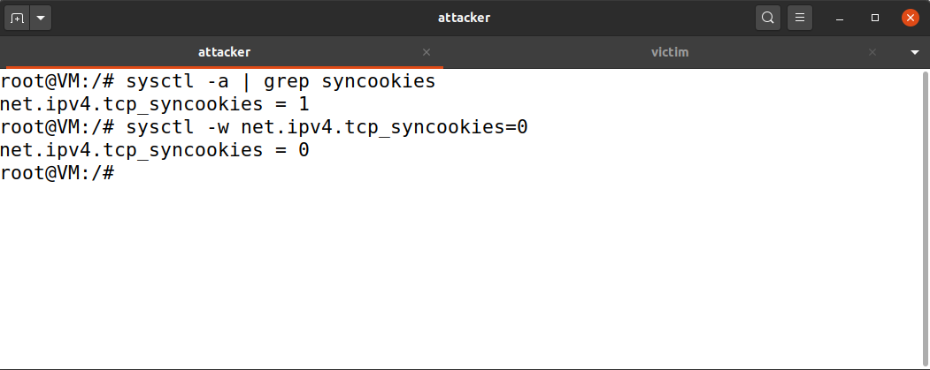

Code for the syn flood

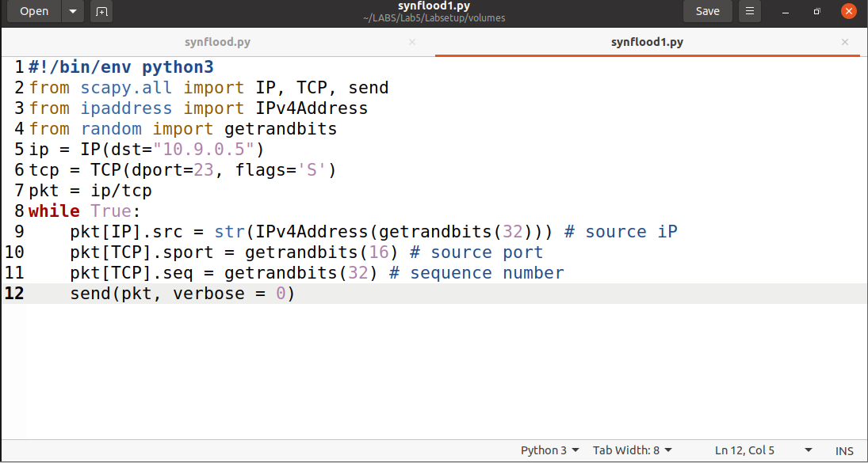

Running the synflood attack from attacker terminal

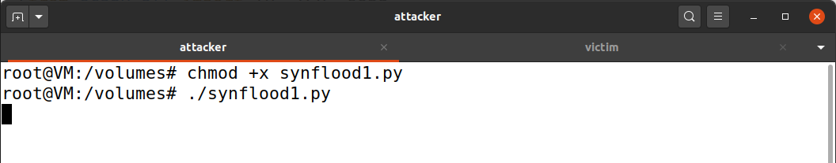

Checking the number of items in queue on victim machine

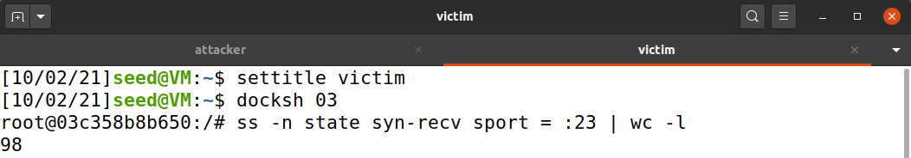

Setting the queue to 60 in victim

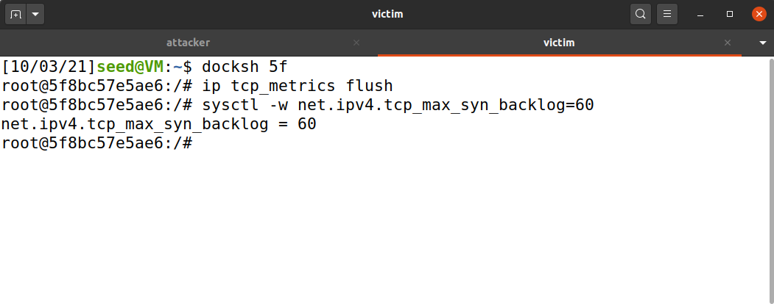

Running the synflood code in 6 terminal to fill the queue

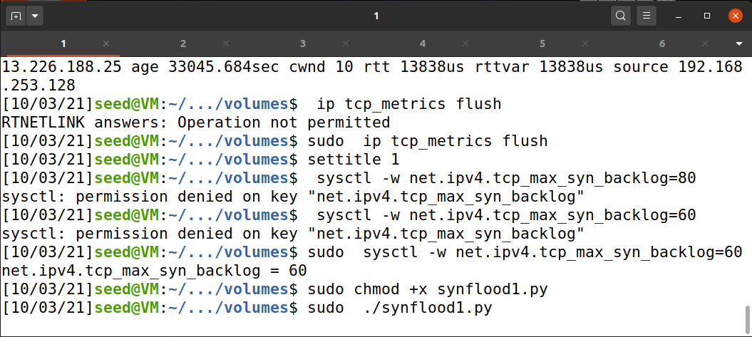

Cannot connect telnet on 10.9.0.5 since queue is filled 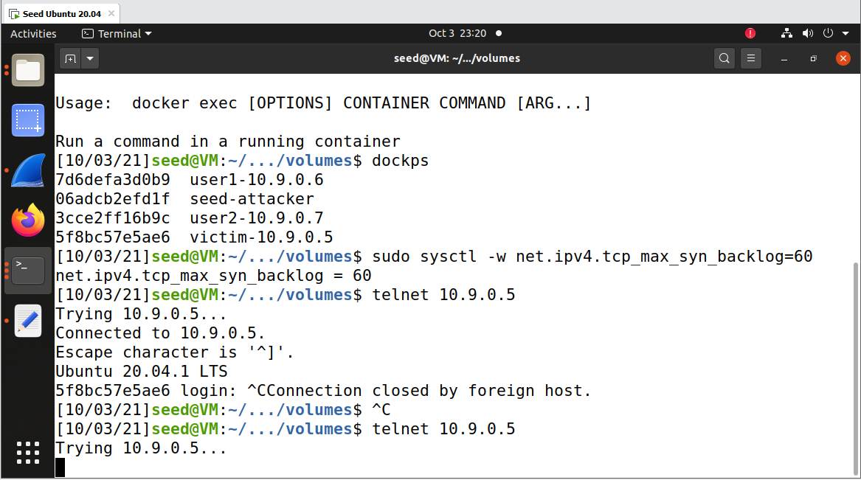

Net stat –n on victim

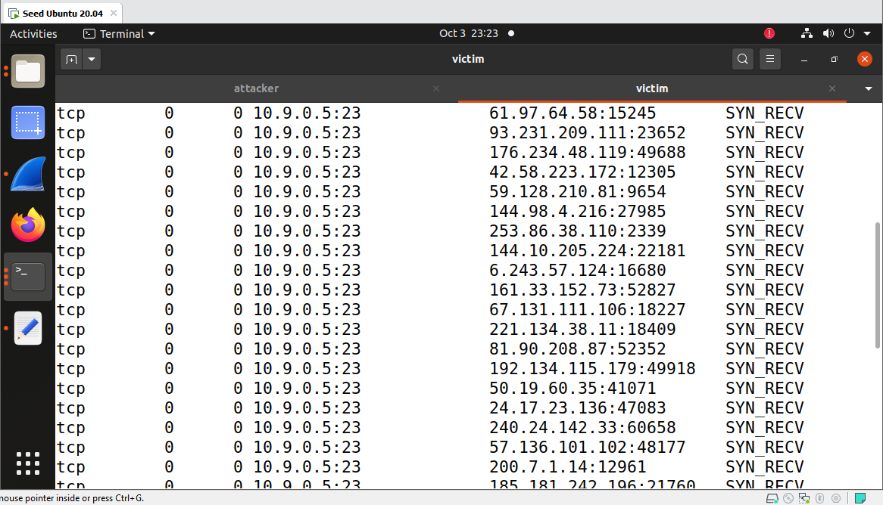

# Task 1.2

Running the synflood.c 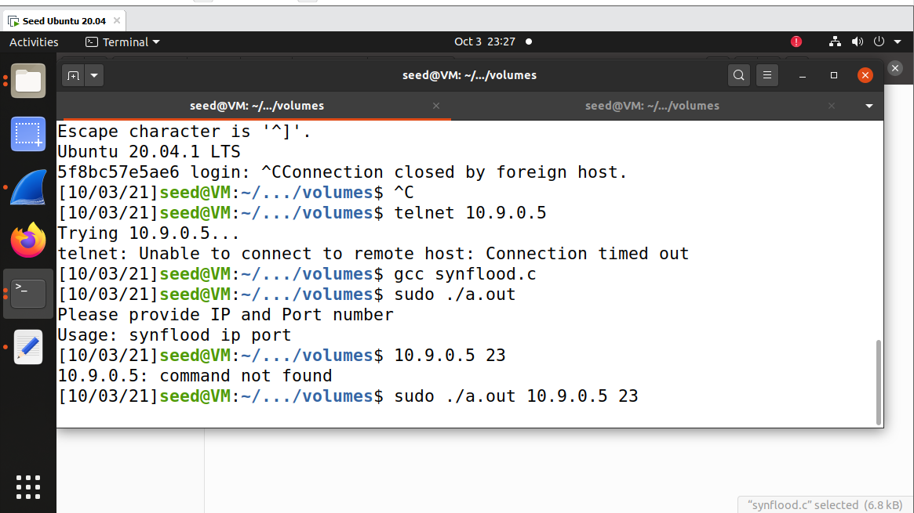

Giving the victim ip and port number



Unable to connect to 10.9.0.5 using telnet 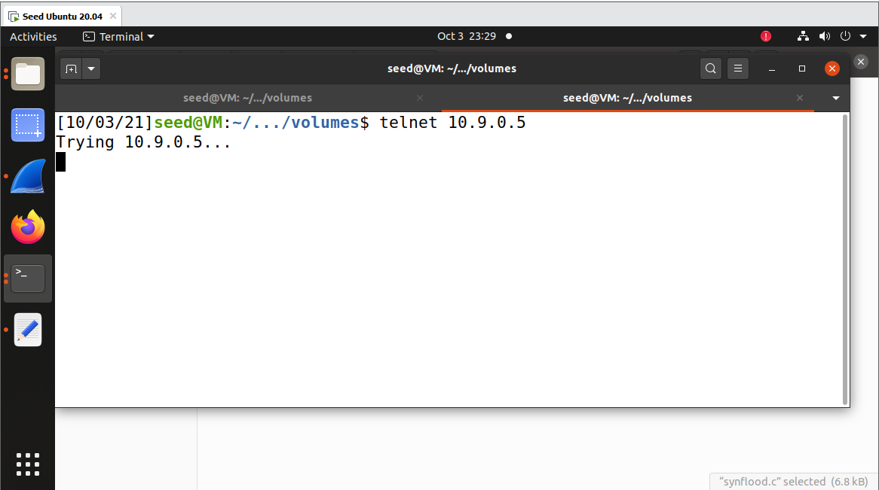

Turning on sync outer measure

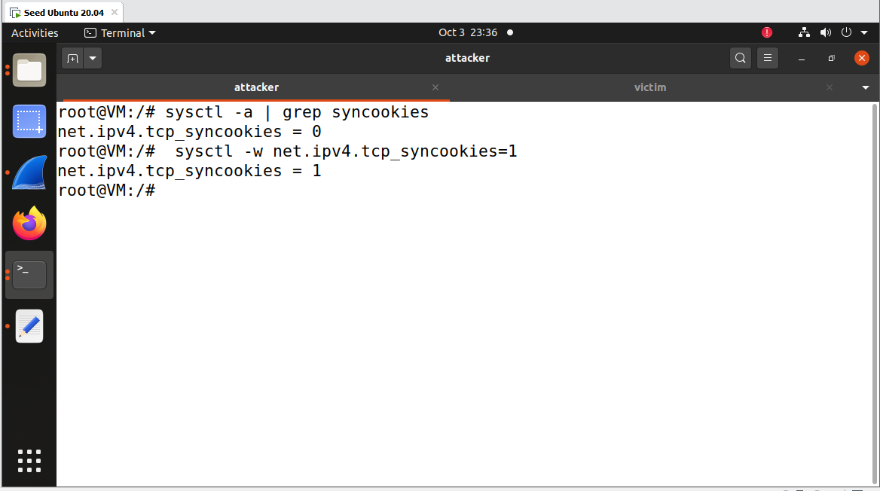

Setting back the syn backlog to max

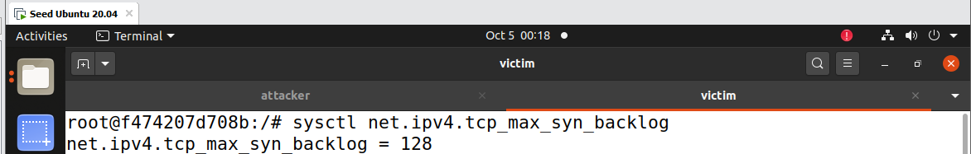

Telnet connection was successful when we run using python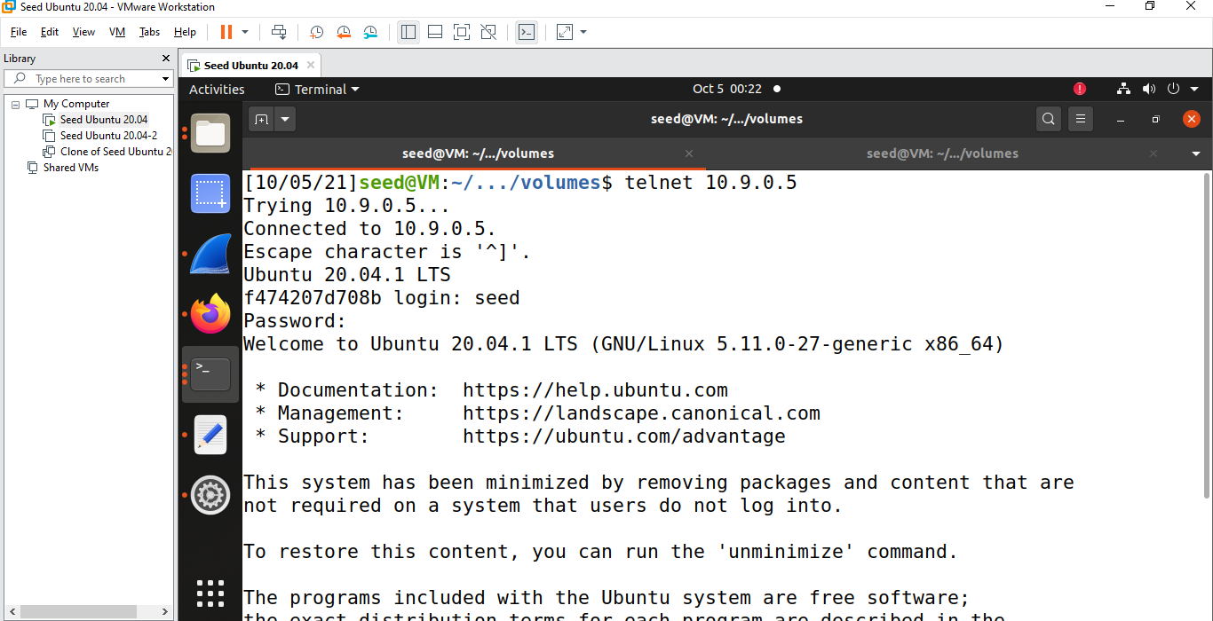

Flush the ip

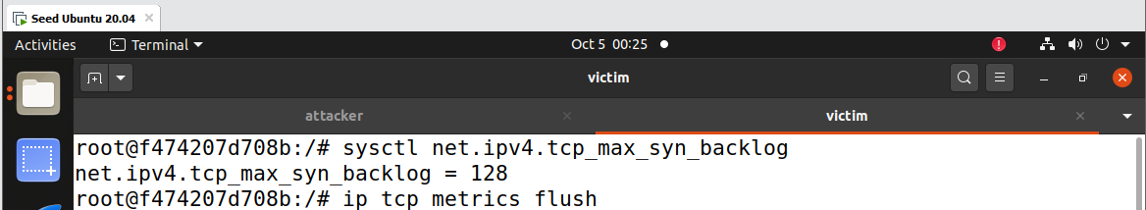

Running the code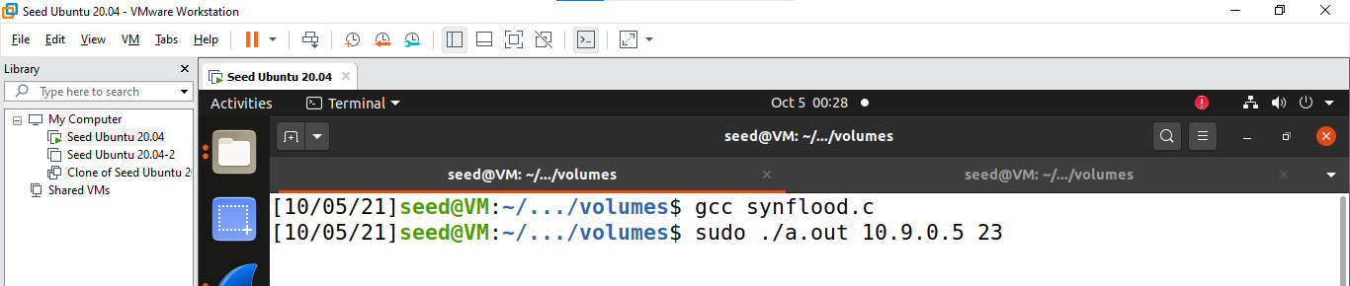

Since we run using the c code the syn flood attack is successful couldn’t create the telnet connection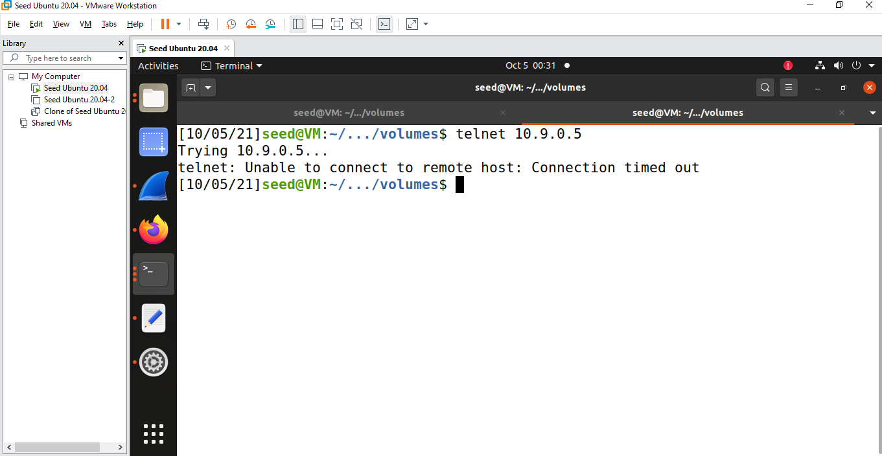

# Task2

Telnet 10.9.0.7 from user 1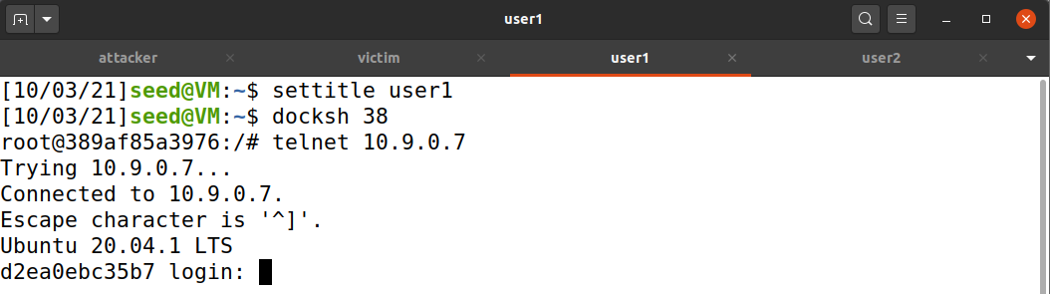

Post login getting the ack and seq number from wireshark

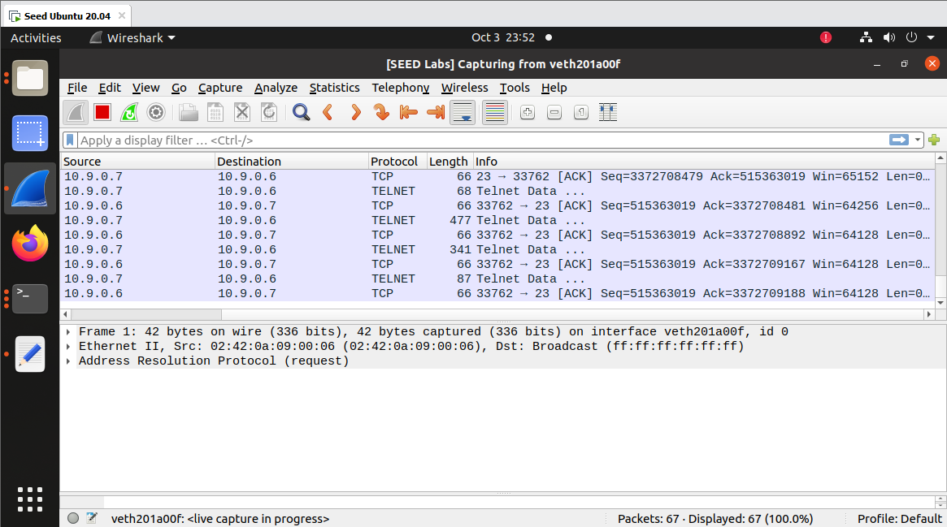

Running the Rst code from terminal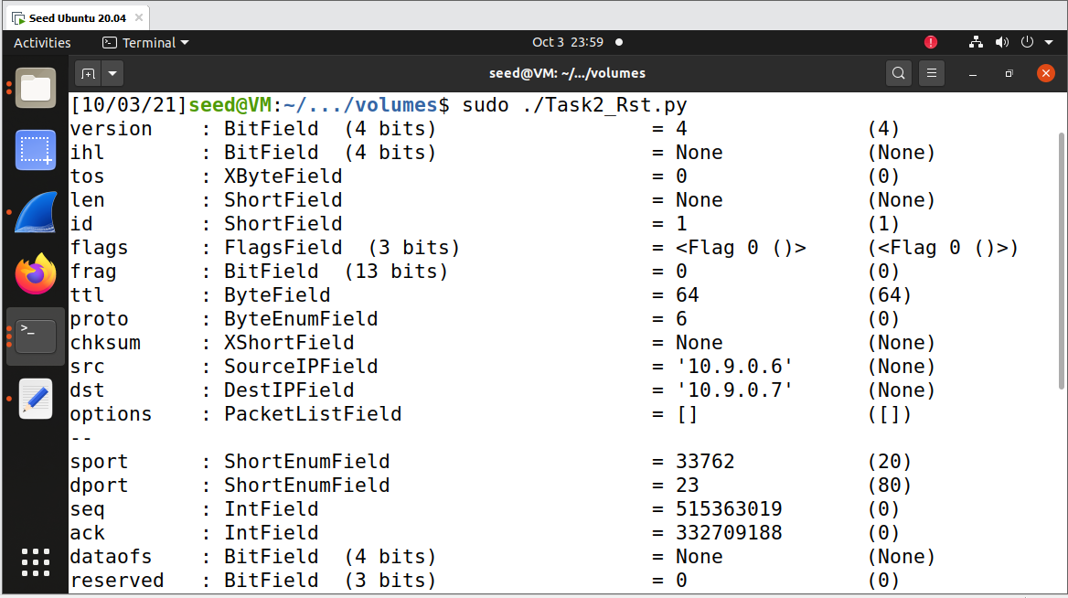

Telnet Connection has been closed post running rst attack

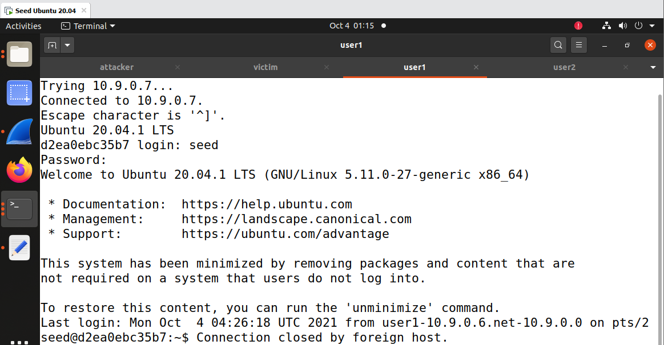

Telnet login from user 1 to user 2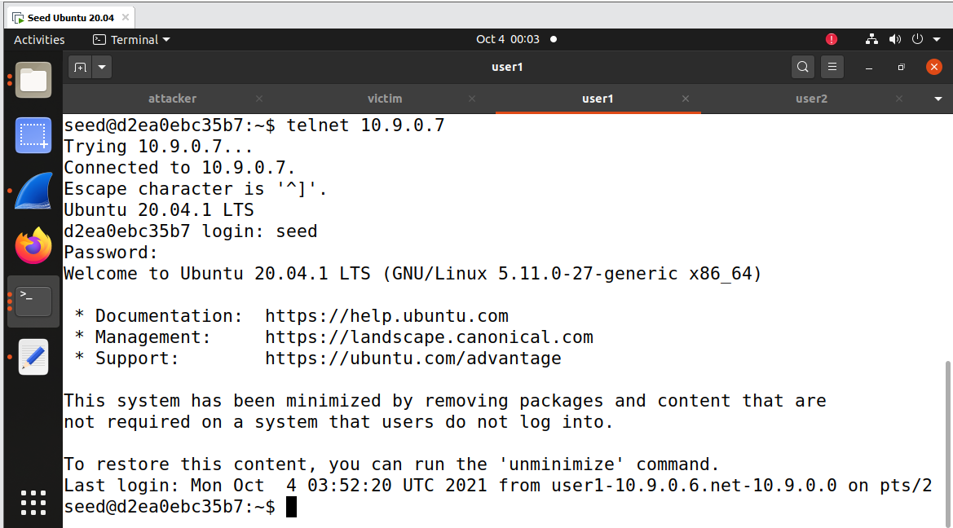

Code for Automatic Rst attack

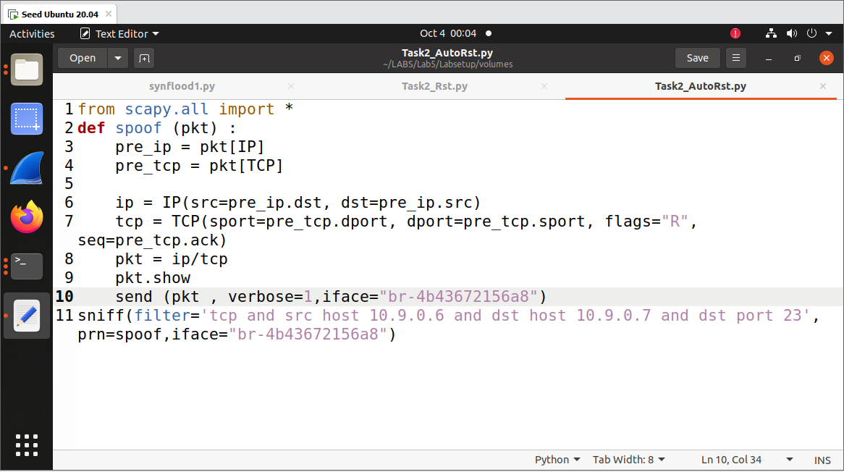

Connection is closed on pressing any button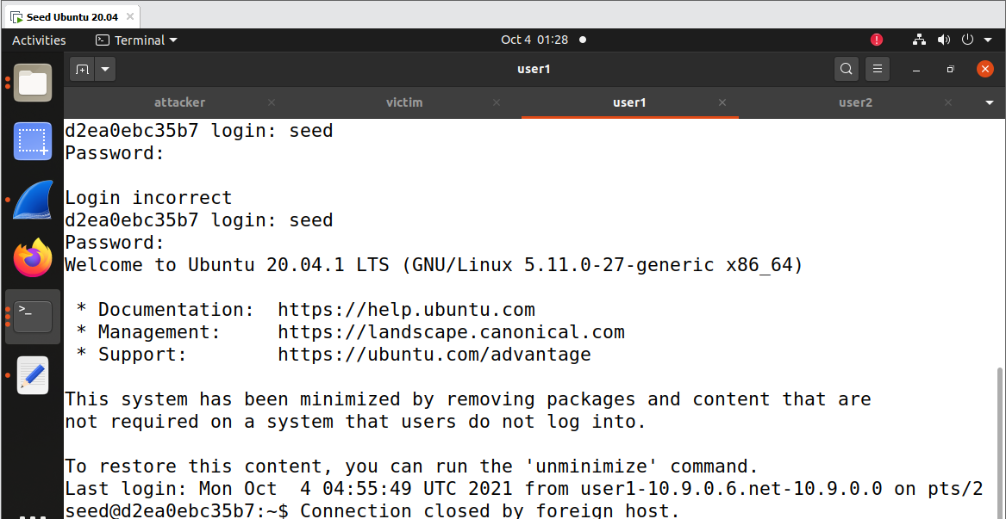

## Task3:

Code for hijack session 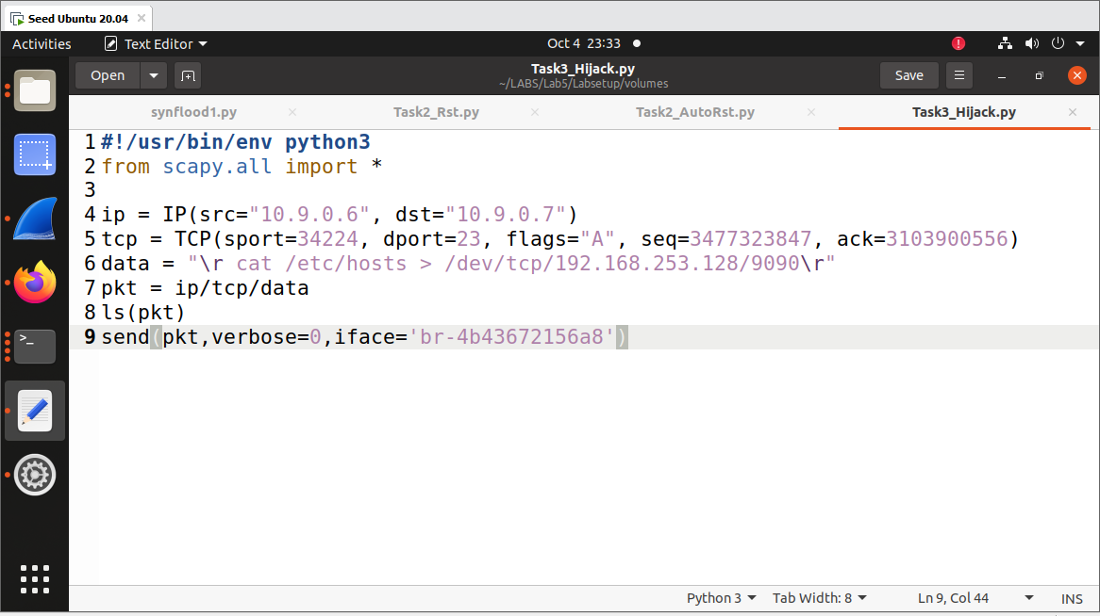

Listening on port 9090

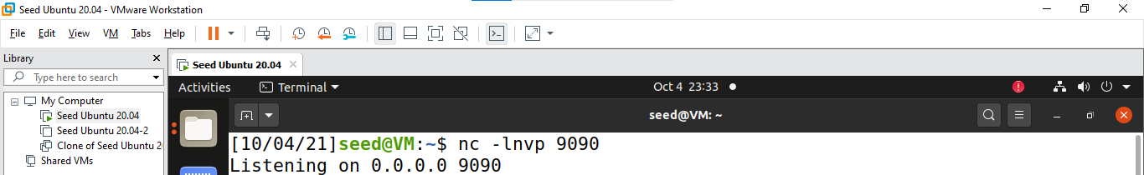

Telnet connection between user 1 and user 2

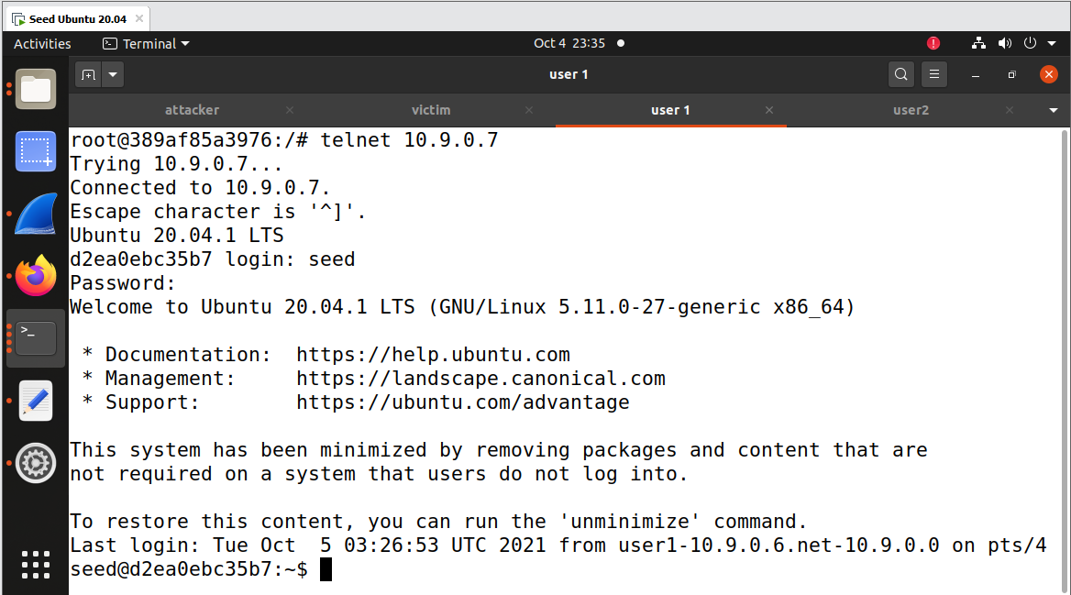

Running the code

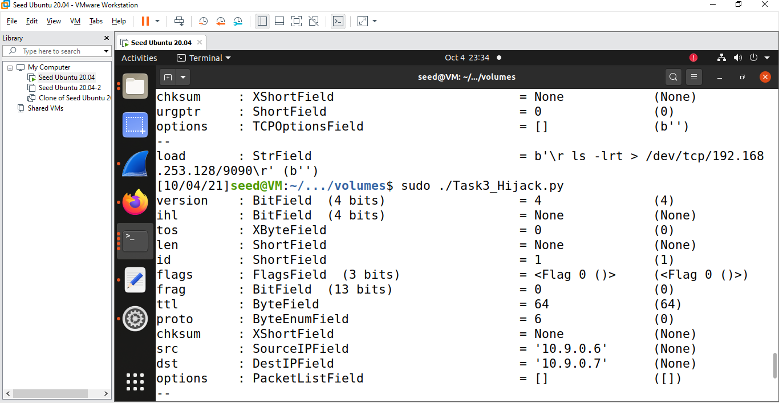

Post running the session hijack code out display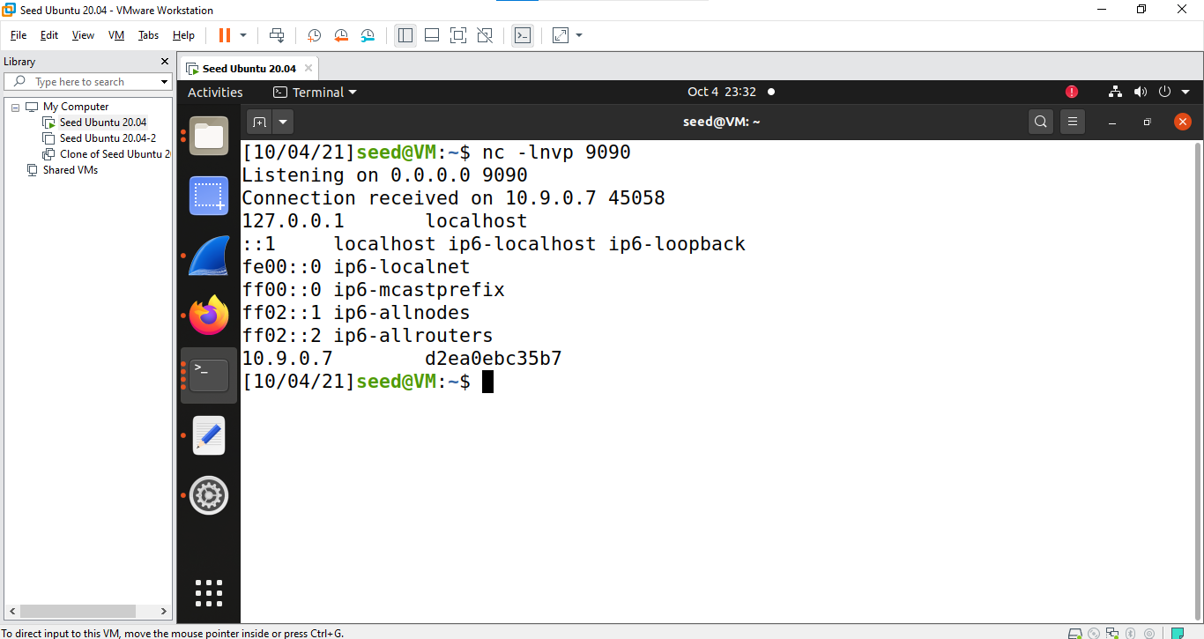

# Creating auto hijack attack

Creating Telnet Connection between user 1 and user 2

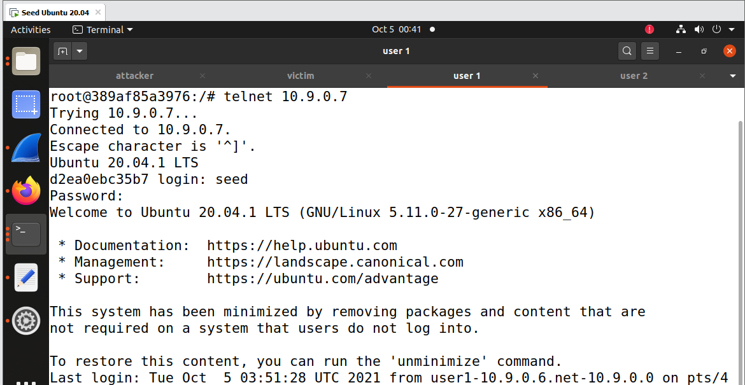

Auto Hijack code

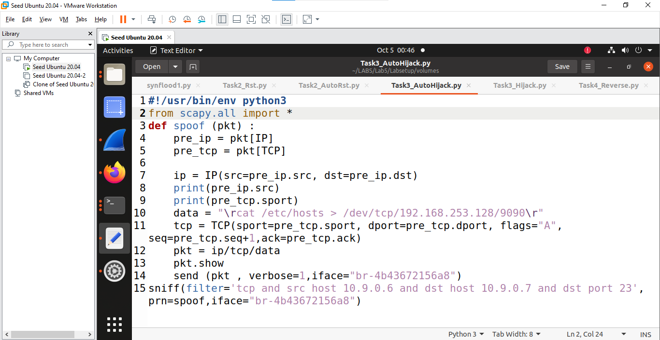

Running the auto hijack code

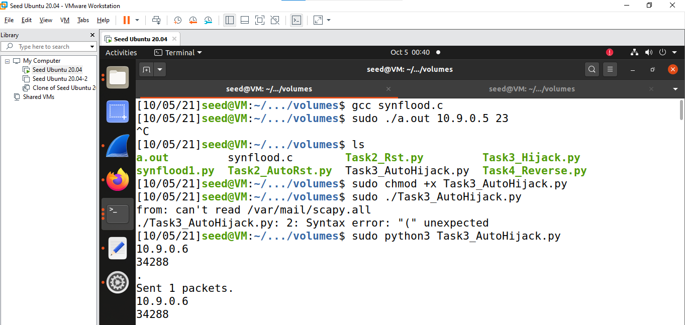

Successful Auto Hijack is done

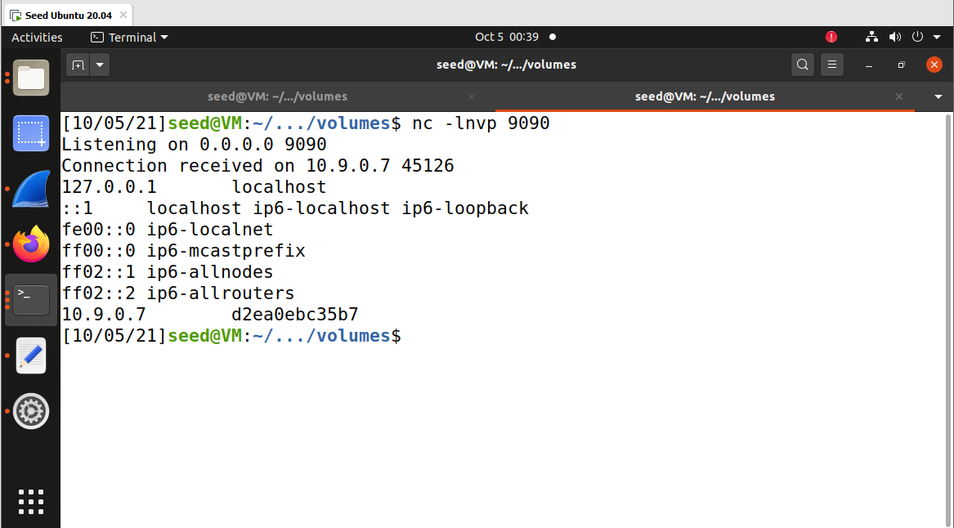

# Task 4

Creating connection between user 1 and user 2

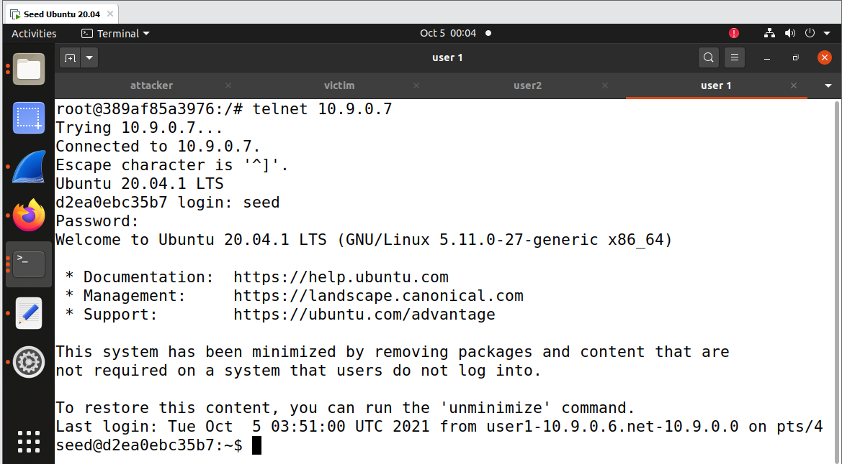

Wireshark output while telnet 10.9.0.7 from 10.9.0.6 for seq number and acknowledgement number

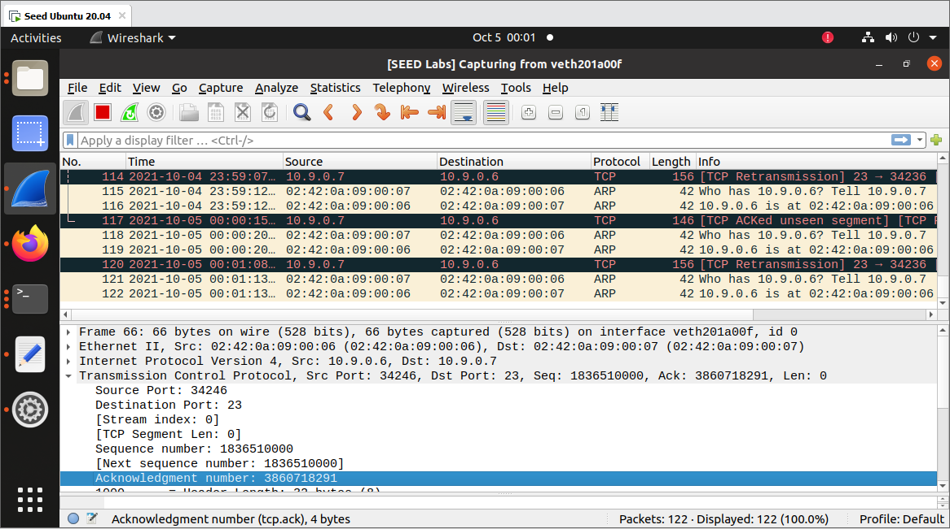

Listening on port 9090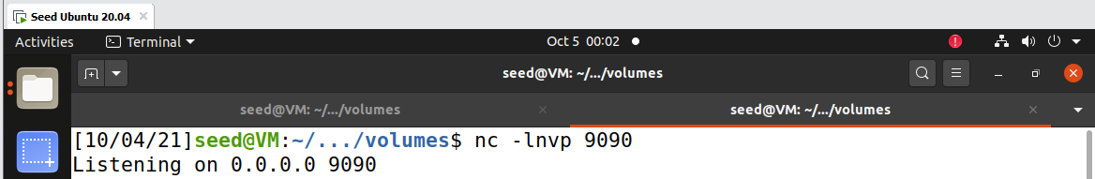

Code for reverse shell

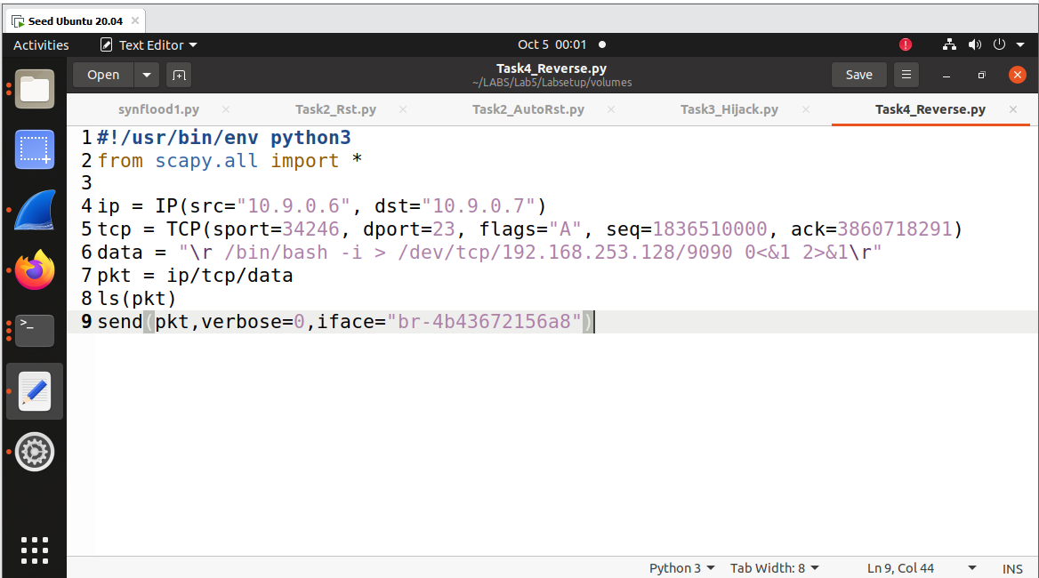

Running the code

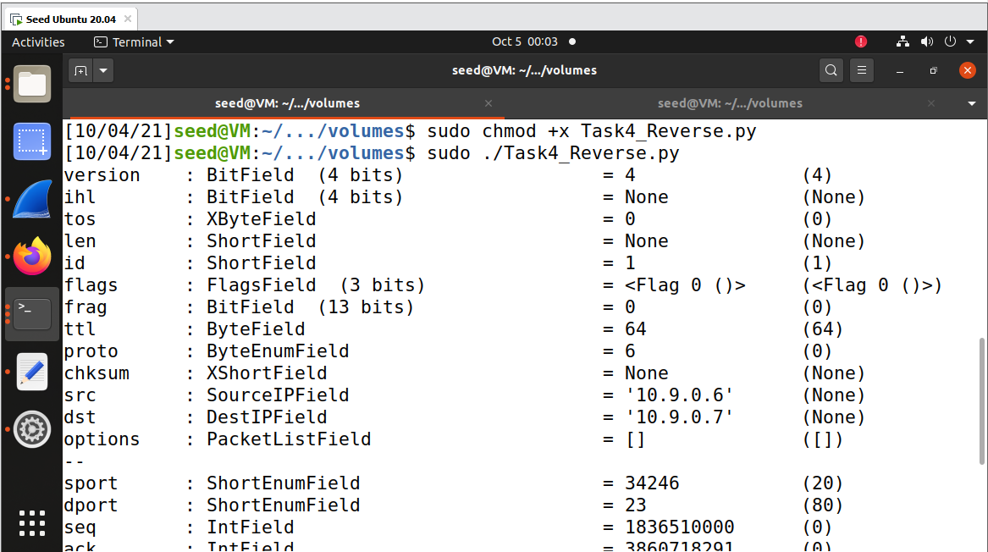

Successfully reverse shell has been done 